


How to Implement Zero Trust Device Security with Trusted Zero Clients and the HP Anyware Trust Center
Holistic Zero Trust is an increasingly mandated and critical defence against cyberthreats especially in today’s hybrid work environment. The added demand for remote access to corporate applications driven by business continuity, customer reach, and newfound employee satisfaction comes with a heightened concern over data security. Employee flexibility aside, enterprises have a competitive need to expose data to contractors and partner eco-systems, which can potentially lead to substantial liabilities if data is compromised.
Which is why cybersecurity has been promoted from the purview of the chief security officer (CSO) to a boardroom environmental, social, and corporate governance (ESG) responsibility. Issues related to data privacy and security have crossed the boundaries of risk management, and now have a tangible impact on workplace and consumer safety.
In a global environment where data is at increased risk from bad actors with access to sophisticated technology, traditional perimeter-centric safeguards, such as firewalls and Virtual Private Networks (VPNs), don't stand up to modern threats from outside the perimeter. In fact, internal networks no longer offer implicit trust either. Which is where Zero Trust comes in.
Zero Trust principles are aimed at improving cybersecurity and have been mandated in the federal arena since 2022. Most vendor offerings typically seek to address siloed segments, such as network or endpoint security, identity, or data security. But it’s important to note that digital workspaces and hybrid work reach across these security segments requiring close alignment between various security and IT teams, in addition to interoperability between security tools.
HP Anyware⁽¹⁾ is a secured access enterprise software product offering zero trust user authentication and endpoint device management strategies. Only authenticated users and trusted endpoints are granted access to corporate workloads. And because software applications are contained to centralized systems, corporate data remains centralized too and never leaks to endpoints, no matter where the user is located.
In this whitepaper, we explain how businesses use HP Anyware with Zero Trust device security to improve cybersecurity posture and build a foundation for corporate-wide trusted digital workspaces.

About Zero Trust
The Zero Trust philosophy can be described as ‘never trust, always verify’, a phrase attributed to John Kindervag under employment at Forrester Research over a decade ago. Forrester redefine modern Zero Trust ⁽²⁾ as:
An information security model that denies access to applications and data by default. Threat prevention is achieved by only granting access to networks and workloads utilizing policy informed by continuous, contextual, risk-based verification across users and their associated devices. Zero Trust advocates these three core principles: All entities are untrusted by default; least privilege access is enforced; and comprehensive security monitoring is implemented.

The updated Forrester definition is particularly relevant in the context of digital workspaces and offers businesses practical guidance. We’ve illustrated the difference between traditional and Zero Trust security architectures in the diagram below.

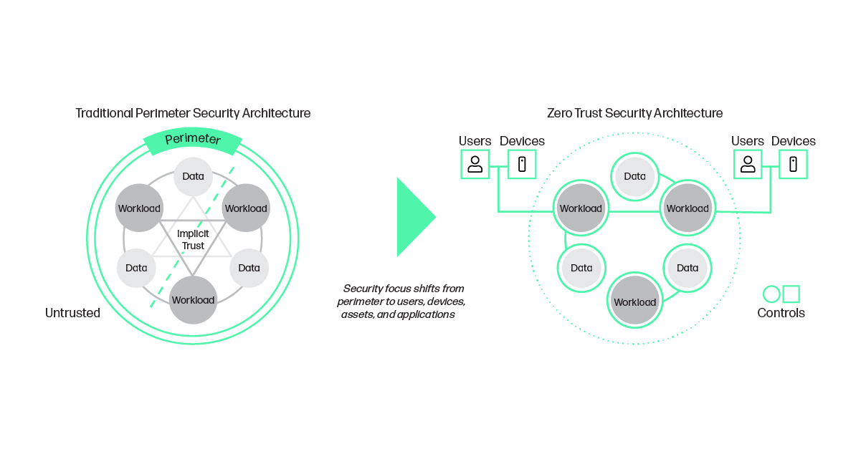

Zero Trust principles
Zero Trust adopts a least privilege access model. This policy mandates secure and authenticated access to only the applications and data that employees require to perform their jobs for defined access periods. Users are first authenticated, as are any devices attempting to link to corporate data. This key Zero Trust principle ensures that only authenticated users with authorized devices can access computing services and business information on a per-session segmented basis in a secured manner, regardless of network location. More recently, the concept of contextual data awareness has emerged as an important improvement to user experience by reducing unnecessary barriers to accessibility.
Zero Trust principles also include real-time monitoring of the integrity of applications and devices, which are supported by robust logging, analytics and reporting. These principles are necessary for providing actionable data pertaining to the state of enterprises resources. The information logged can be used for both short term rapid or automated response mechanisms and the ongoing objective of improved security posture.

What are the benefits of Zero Trust?
One of the biggest benefits of Zero Trust is that it enables adaptive and secure ways to connect and collaborate with digital business ecosystems, including remote workers and partners. According to the American Council for Technology-Industry Advisory Council (ACT-IAC), Zero Trust benefits for digital workspaces include:
- Building a more secure network
- Allowing IT decision makers (ITDM) to focus on data safety
- Improved protection against exiting and evolving threats
- Reduced impact from security breaches
- Improved compliance and visibility
- Potential cost reduction

Zero Trust also has cross-segment impact, including network security, endpoint security, identity and digital trust, and information and data security.

Evolving threat landscape and a new work paradigm

When the COVID-19 pandemic compelled many employees to work from home, a massive paradigm shift occurred in the way companies conduct business. Remote work afforded employees a type of workplace flexibility they hadn’t encountered before—they were able to work from home, or anywhere else, while still being productive, and while achieving better work-life balance.
For businesses, cloud adoption and remote work allowed them to widen their reach, employing people from around the world. By investing in digital workspace software, companies could offer their employees a comparable user experience that they would have within the office even if they were located at the opposite end of the world.
The possibility of remaining remote, or partially remote once local mandates eased became a reality, with businesses first exploring and then adopting hybrid working models. Momentum around digital workspace initiatives picked up as did the urgency around risk reduction and improving security.
Ensuring better data security across the company, especially when employees are located outside the office and using a multitude of devices, both company-managed and personal, has encouraged more CSOs to adopt Zero Trust initiatives.

Continuous trust is key to the future digital workspace
A digital workspace might best be defined as a secured, work-from-anywhere, integrated technology framework that can deliver, manage and control centralized company assets, including applications, data and desktops. Organizations can choose to build digital workspaces accessible from multiple locations and devices. Businesses can secure access to their digital workspaces by deploying PC-over-IP (PCoIP®) powered display software HP Anyware. By adding trusted endpoint security, identity management, policy driven authorization, continuous monitoring and eXtended Detection and Response (XDR), these workspaces will encompass the key tenets demanded in the modern cyber-landscape.

Device trust as a pillar of Zero Trust
Security policies in remote work environments have largely focused on user identity with multi-factor authentication (MFA) and federated authentication as more recent baseline requirements. Identity is one of the five distinct pillars forming the foundation of Zero Trust, according to the Zero Trust maturity model of the Cybersecurity and Infrastructure Security Agency of America (CISA).
The second pillar is centered in device trust. The model entails not just validating user identity, but also ensuring compliance of the access devices that are used. Particularly in regulated industries, the security of these devices needs to be managed to ensure a baseline of device security protections and visibility into the security posture of devices themselves. This endpoint focus allows for device compliance and integrity to be included as part of the access control decisions for services and data. The remaining three pillars are Network, Application Workload, and Data.

HP Anyware advances your Zero Trust strategy
Based on PCoIP technology, HP Anyware is a digital workspaces solution that offers businesses flexibility, security, productivity, and collaboration from virtually anywhere. The PCoIP protocol prevents any need for corporate data to be transferred from the digital workspace to the user’s device. Instead of using traditional VPNs, which are susceptible to corporate data exposure, only AES-256 encrypted image pixels are transmitted from the data center to the endpoint, significantly decreasing access for hackers.
When Zero Trust principles are paired with HP Anyware, businesses can develop even higher levels of data security. Firstly, users are subject to MFA authentication enforcement before gaining access to their digital workspace. Secondly, HP Anyware used in conjunction with the Anyware Trust Center and trusted PCoIP endpoints can ensure no unauthorized access to corporate data, and no ability to execute malicious applications, all while offering continuous monitoring of endpoint security posture.
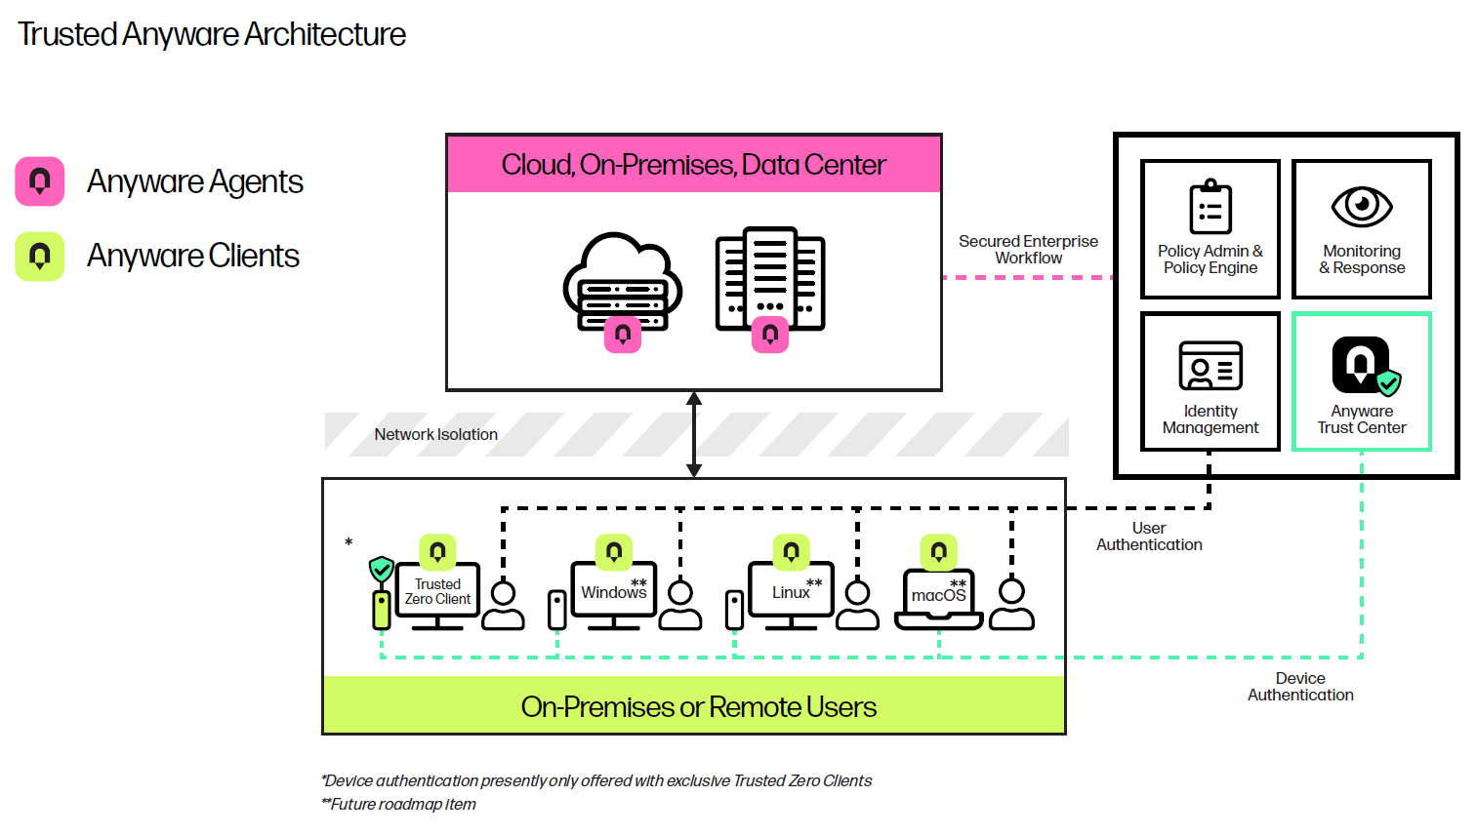
The Anyware Trust Center offers IT teams a highly scalable future-ready approach to achieving Zero Trust best practices for endpoint device security. Not only does the architecture enforce clear segmentation between user authentication and device authorization services, but when deployed in conjunction with PCoIP Trusted Zero Client endpoints, stringent levels of digital workspace security can be achieved. Government agencies seeking advanced levels of device security can leverage Anyware Trust Center capabilities to accomplish higher levels of Zero Trust maturity.
While device trust is fundamental to any zero trust architecture, functional security requirements are varied depending on compliance mandates or risk assessment. For example, an enterprise division with a bring your own device (BYOD) policy may be comfortable with less stringent functional device requirements than those of a high classification federal agency. HP Anyware offers customers the desired deployment flexibility from unmanaged endpoints, through thin clients, or third-party device authentication products to the highest security Trusted Zero Clients. The table below provides more detail about each option.
 | Thick Client (Desktop Client) | Thin Client | PCoIP Zero Client (Tera2) | Trusted Zero Client
What is it? | PCs with operating system running client software that connects to a remote or virtual computer desktop. | Managed lightweight computer devices with a lightweight operating system running (multiple) client software and other applications that connect to a remote or virtual computer desktop. | Dedicated hardware to run a single client application with the purpose to connect to remote or virtual computer desktops. No fan, no moving parts, nor local storage. | Dedicated hardware to run a single client application with the purpose to connect to remote or virtual computer desktops. No fan, no moving parts, nor local storage. Additional Zero Trust features managed by a Trust Center.
Lifespan | 4 years. A model is typically only available to purchase for a single year making standardization more challenging. PC is typically replaced every 3-4 years. | 6-7 years. Models typically remain available for sale for about 5 years. | 6-7 years. Models typically remain available for sale for about 5 years. | 6-7 years. Models typically remain available for sale for about 5 years.
Operating System | Typically Windows®, but also Linux®, macOS® or Browser. | Typically Win 10 iOT or Linux. | RTOS on chip. | Security enhanced, locked down Linux.
Protocol | Any | Any, although certain models may limit protocol options | PCoIP | PCoIP, PCoIP Ultra®, VMware Blast (future feature)
PCoIP Ultra Performance | With the widest range of processor options, many PCs will support PCoIP Ultra. However, lower performance processors may not support the necessary AVX2 instructions. | Although some Thin Clients will support higher performing processors with AVX2 compatibility, many, if not most, do not. Lower cost processors with lower heat generation are typically a leading design directive. | Excellent PCoIP performance, especially when paired with a Remote Workstation Card (purpose build protocol hardware chips). However, PCoIP Ultra is not supported. | Purpose built to support PCoIP Ultra. Multiple configurations available to meet different use cases - from a typical office worker to a graphics heavy design professional. All models will support PCoIP Ultra.
Level of ongoing maintenance required | Windows desktops require frequent updates, often requiring a complex infrastructure and multiple management applications. More complex hardware configurations also lead to additional component failures and greater field support costs. Additional software applications will require additional security monitoring tools. | Thin Clients as a class are easier to maintain as they typically have a minimized OS with few applications since they are designed primarily to use to connect to virtual desktops. They also typically do not have any moving parts reducing hardware maintenance in the field. Embedded Windows variants that are sometimes unlocked can add additional maintenance overhead, however. | A single firmware image for easy maintenance, PCoIP Zero Clients are one of the easiest endpoints to manage. They do not have any moving parts reducing hardware maintenance in the field. | Minimal maintenance needed like PCoIP Zero Clients (TERA2), plus all firmware updates are initiated and managed through HP Anyware Trust Center.
Malware Vulnerability | Running on any OS with multiple applications, typically thick clients on desktops deal with a variety of attack surfaces that need to be dealt with on a daily basis. | Most thin clients limit user data and applications as well as have some level of hardening or write filter, limiting attack vectors. However, some thin clients can have more open configurations leading to slightly elevated risk. Any system running multiple applications will have increased risk. | Single purpose build application, with no access to OS, Bios, no local applications, and no local data, limiting malware attack vectors. | Single purpose build application, with no access to OS, Bios, no local applications, and no local data, limiting malware attack vectors.
Vulnerability to locally stored user data | User data stored locally, leading to vulnerability to loss, theft, and malware attack. | Thin Clients do not typically store user data locally, although they can be configured to allow it. | No user data is stored locally. | No user data is stored locally.
Locked down OS/BIOS | OS and BIOS is not typically locked down leading to malware and security vulnerabilities. | Access to OS and BIOS is typically restricted, although not always locked down. Access to install additional applications is not uncommon. For Windows Embedded variants, the write filter may be disabled leaving the OS open. | No access to operating system or BIOS. | Locked down firmware with direct secure boot into the Trusted Zero Client application to prevent users from tampering with firmware, BIOS, or OS.
Designed with Zero Trust Architecture as recommended by NIST | No | No / Maybe | FIPS 140-2 Level 1 validated by NIST | Establishes a chain of trust between the Trusted Zero Clients and Anyware Trust Center; monitors Trusted Zero Clients continuously for any anomalies; Supports FIPS 140-3 Level 1 (certification in progress)
Validate integrity of endpoints on every connection | No | No | No | An immutable signature birth certificate is created at factory which is validated by the Trust Center. The integrity of the endpoint is validated on every connection to ensure compromised devices can be controlled based on set policies.
Manageability | Enterprise class management tools are typically not included with a system and are optional. Because of the vast diversity of applications and hardware configurations, the tools to manage the environment are more complex and costly. | Easy to use Enterprise level Endpoint Management Software offering streamlined deployment. Management tool typically limited to OS vendor of thin clients. | Easy to use Enterprise level Endpoint Management Software offering streamlined deployment. Teradici management tool for all HW manufacturers Zero Clients. | Anyware Trust Center to manage all Trusted Zero Clients (from all vendors), added Zero Trust security policy features, monitoring. Trust Center can be managed from a variety of industry available client endpoint management tools.
Best suited for | On the road use of laptops, for less security minded operations. | Multi-protocol/vendor use. | Security conscious organizations limiting the risk of data breach. | Security conscious organizations limiting the risk of data breach and with mandates to implement Zero Trust principles in their organization.
What to consider when purchasing clients | Central management; Processor power; AVX2 support; Number of displays, Resolution; Noise levels; Field maintenance; Security required with data on endpoint, Number/types of USB, User type (task worker to power users)

best
poor

Lifecycle security
As depicted in the table, enterprise architectures that incorporate Trusted Zero Clients offer holistic lifecycle device security from supply chain through operational deployment, when compared to full featured devices or thin clients. The key component of this lifecycle security posture is the Anyware Trust Center, a software extension to the vendor-supplied Endpoint Manager which is required as the basis for local operational trust. The Anyware Trust Center serves to onboard, manage, monitor, and update devices via the administrative console of the Endpoint Manager, in addition to serving as the device service hub for Endpoint Detection and Response (EDR) or Security information and event management (SIEM) production tooling. The Anyware Trust Center offers these device trust enhancements to endpoint management solutions available from several vendors. Currently, the Anyware Trust Center responds with remediation if the device is not from a Trusted Factory™. Otherwise, IT admins can manage policies using their own policy engine via Trust Center APIs. For SIEM, the Anyware Trust Center provides continuous reports of the endpoint so that admins can respond if a device is not in compliance.
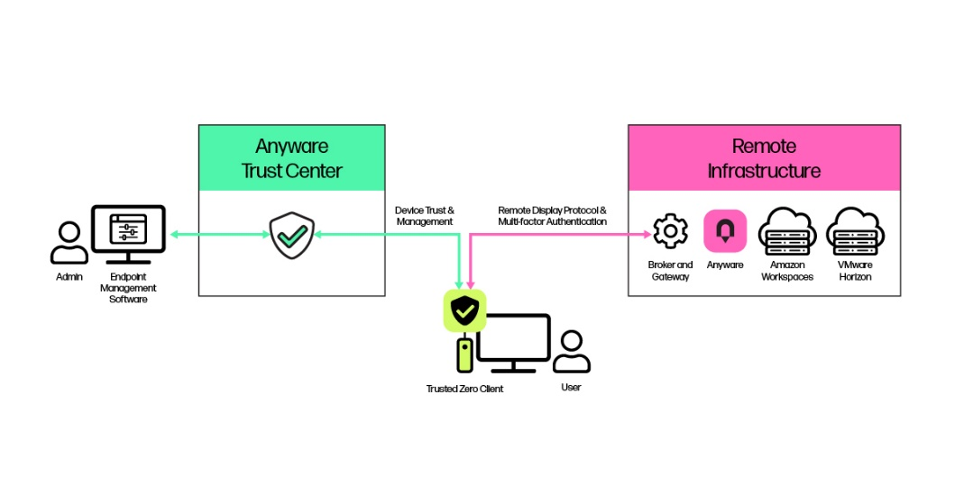

Operational trust
Supply chain security begins with trusted device identity. Trusted Zero Clients incorporate a unique factory-generated birth certificate indicating authorized manufacture. These birth certificates form the life-long root of trust as the Trusted Zero Client onboarding process requires this birth certificate to be presented as proof of identity to the Anyware Trust Center. Once the device identity is validated, the Trusted Zero Client receives a conditional operation certificate from the Trust Center, allowing conditional connectivity to HP Anyware digital workspaces. If the presented birth certificate is invalid or an existing operational certificate revoked, authorization is withdrawn, and the PCoIP connection capabilities of the Trusted Zero Client are disabled.

Secure boot and update
Trusted Zero Clients also adhere to the Integrity Management Architecture (IMA) standards developed by the Trusted Computing Group (TCG). These standards ensure secure boot and only permit authorized firmware execution. IMA prevents the Trusted Zero Client from loading any malicious firmware, which might be injected via supply chain tampering. Because Trusted Zero Clients have no console or access to the BIOS or OS, the secure boot process cannot be bypassed by users or threat actors. When a Trusted Zero Client receives an over-the-air (OTA) firmware update package, the package is verified by the trusted operating environment before enablement.

Provisioning for compliance
Once onboarded using birth certificate validation, Trusted Zero Clients should be provisioned to meet the device compliance requirements mandated by security and network operations teams. These include firmware versioning, Anyware Connector assignment and USB peripheral permissions. Trusted Zero Clients submit firmware version information to the Anyware Trust Center, and IT admins can mark devices as untrusted or force a software update if the firmware version violates policy.
Assigning Trusted Zero Clients to specified Anyware Connectors allows enterprises to execute a phased and segmented transition to Zero Trust without impacting their digital workspaces. By grouping devices and their assigned Connectors according to security posture, IT teams can maintain segmented pools at different security levels and methodically phase out legacy pools of low compliance devices.

Continuous monitoring
The Anyware Trust Center abides by the Zero Trust principle of continuous monitoring. Conditional short-life operational certificates are periodically issued to each Trusted Zero Client. The Trusted Zero Client is required to verify its birth certificate each time a new operational certificate is requested. Continuous monitoring of certificates ensures that when a device is compromised or stolen, it cannot be used to access company data.

Incident response
The Anyware Trust Center receives and stores audit log events from connected devices. By binding the Anyware Trust Center to corporate Security orchestration, automation and response (SOAR) tools, automated response systems can be extended to include Trusted Zero Clients and the Anyware Trust Center itself. These automations ensure a rapid response to any security incidents, so company information isn’t compromised.

HP Anyware facilitates the key pillars of government agency Zero Trust
According to the CISA Zero Trust Maturity Model, functional aspects of device trust can be incrementally improved from manual-oriented traditional approaches with limited visibility into compliance towards ‘advanced’ and ‘optimal’ Zero Trust methods. This advancement can be achieved through an increased reliance on automated processes and systems used for policy enforcement. The table below maps several key device trust attributes to the features offered by HP Anyware when used in conjunction with Trusted Zero Clients.
FUNCTIONAL DEVICE TRUST | HP ANYWARE
Compliance Monitoring | Provides continuous measure of device security posture
Data Access | Provides continuous measure of device security posture
ASSET MANAGEMENT | Supported via secure OTA updates, Endpoint Manager asset reporting tools
Visibility and Analytics | Integrates with EDR for continuous posture assessment
Automation and orchestration | Operational certificates support automated policy-driven authorization

Getting started on your Zero Trust journey
Understanding Zero Trust maturity models, such as the model presented by CISA, can help ITDMs and company policy makers evaluate present corporate security posture and identify steps needed to advance their maturity. The CISA model calls out five distinct pillars (Identity, Device, Network, Application Workload, and Data) and three levels of maturity (Traditional, Advanced, and Optimal) which enables incremental restructuring of infrastructure and business practices.
The key is to start with focus instead of trying to make sweeping changes. Besides traditional expertise offered by security consultants, vendors and industry alliances, there are several security-minded user communities, such as Information Sharing and Analysis Centers (ISAC), Advanced Technology Academic Research Center (ATARC), Movielabs, the Open Group and others that offer Zero Trust best practises and reference designs in the context of your industry’s needs.

Trusted Zero Clients and how to buy
Businesses with existing PCoIP Zero Client or thin client deployments can accomplish the trusted device pillar of their Zero Trust strategy by adopting Trusted Zero Clients in conjunction with the Anyware Trust Center. The enhanced management and security features offered by the Anyware Trust Center can be unlocked with an Anyware Trust Center subscription on a per-device basis.
Trusted Zero Clients are available for purchase in various form factors through a wide array of OEM partners⁽³⁾.
Each individual Trusted Zero Client shipped comes with the first year of Anyware Trust Center, a subscription that enables enhanced Anyware Trust Center features, allows zero client firmware to be updated, and support from HP. Renewal is required after the initial year.

About Amulet Hotkey
We believe that partnerships play a key role in our products and solutions’ development, delivery and ongoing success. That is why we work hard to deliver an ecosystem of partners, resellers, and cloud service providers – working together to meet the needs of our customers around the globe.
Learn more about Amulet Hotkey at www.amulethotkey.com

About HP Anyware
With HP Anyware, ITDMs can keep employees productive from wherever they have network connectivity by providing secured access to their digital workspaces without a virtual private network (VPN). Learn more about HP Anyware at www.hp.com/Anyware.

(1) Network access required. HP Anyware software and licensing are available through a 1- or 3-year subscription. Renewal is required after the subscription term. HP Anyware subscriptions are based on the number of concurrent PCoIP connections used (pay for the number of host connections, not the software) with a minimum order quantity of 5. For a limited time, an HP Anyware Professional subscription also includes access and support for ZCentral Remote Boost and ZCentral Connect and is available for purchase through an HP reseller or contact sales at hp.com/Anyware. ZCentral Remote Boost Sender requires Windows 10 and 11, RHEL/CentOS (7 or 8), or UBUNTU 18.04 or 20.04 LTS operating systems. macOS (10.14 or newer) operating system and ThinPro 7.2 are only supported on the receiver side. ZCentral Connect requires Windows (10 or 11) or Windows Server (2016 or 2019) operating system, Microsoft Active Directory and Intel Active Management Technology for select features. For system requirements and to in https://docs.teradici.com/find/product/hp-anyware.
- The Definition Of Modern Zero Trust, Forrester blogs, January 24, 2022.
- Planned for late 2023 availability, See https://teradici.com/resource-center/product-service-finder for compatible endpoint management solutions and trusted zero client offerings.

