Gain flexibility in financial services with the CoreStationTM range from Amulet Hotkey. Remote workstations that give your teams the power to enable agile working.

The infrastructure to work from anywhere

Are you accessing the benefits of remote working?

Giving traders secure access to trading platforms from anywhere, at any time, can boost agility and resilience, reduce long-term operational costs and give you access to the right talent. However, it’s only possible with secure, resilient access to business-critical platforms.

Engineered from the outset for remote access at high density, our CoreStation™ range of remote workstations provides the technology on which to build your remote access compute resource. We empower financial organisations to respond swiftly to change and enable their employees to work from anywhere, with no compromise on performance. Providing even the most demanding users with secure, remote access.

It's all made possible by combining powerful, dedicated remote workstations with our class-leading virtual desktop infrastructure (VDI) capabilities. Our solution improves operational agility and helps to withstand any disruptions in the workplace, whilst maintaining the high performance, secure and uptime that traders experience in the office.

www.amulethotkey.com

60%
Around half of traders work from home 60% of the time¹

93%
of UK financial services staff would like to work remotely at least some of the time²

35%
of employers found their teams are collaborative when working remotely³

- https://www.thetradenews.com/number-of-traders-suffering-mental-health-issues-doubles-in-2022-finds-survey/
- https://www.hireiq.co.uk/job/blog/does-remote-working-work-in-the-financial-industry
- https://www.talktalkgroup.com/newsroom/2020-lockdown-lessons

Key features
(icons on https://www.amulethotkey.com/products/remote-workstations/)

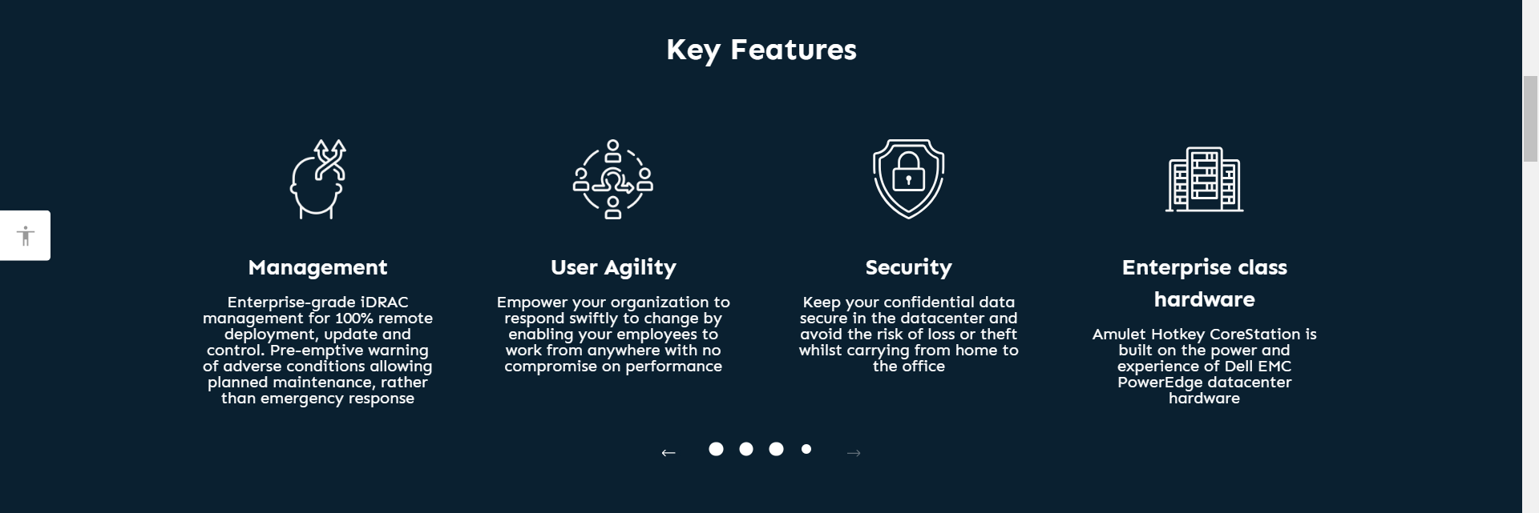

Performance
Single and Dual socket Intel Xeon and AMD EPYC processers up to 128 cores per workstation.

Enterprise-grade reliability
Error correcting memory and redundant, fault tolerance storage, power, cooling and network.

Ground breaking density
Best in class density for dedicated workstation and VDI deployments to keep data centre costs to a minimum.

Management
Enterprise-grade iDRAC management for 100% remote deployment, update and control.

User agility
Empower your organisation to respond swiftly to change – enable employees to work from anywhere with no compromise on performance.

Security
Keep your confidential data secure in the data centre and avoid the risk of loss or theft when carrying from home to the office.

Enterprise class hardware
Built on the power and experience of Dell EMC PowerEdge data centre hardware

